

Use Case Specification: CSR eCL Quality Feed
For

eCoaching Log

Change History Log

Date | Version | Description | Author
09/18/2014 | 1.0 | Initial Document | Doug Stearns
11/17/2014 | 1.1 | P13826 – IQS/eCL Source Values  Added alternate flows 4.6 and 4.7  Note: actual value for sources is not yet known | Doug Stearns
12/01/2014 | 1.2 | P13891 – eCL Original Hierarchy  Inserted 3.24, 3.25, following items re-numbered  Modified Figure 1 | Doug Stearns
08/03/2015 | 1.3 | TFS413 – IQS/eCL new Verint-GDIT Supervisor source  Added 4.8 Verint-GDIT Supervisor Source  Modified Figure 1 | Doug Stearns

Table of Contents

1. Brief Description 6
2. Participating Actors 6
2.1 Primary 6
2.2 Secondary 6
3. Basic Flow of Events 7
3.1 System process executes at the scheduled time. 7
3.2 Input file accessed from appropriate folder. 7
3.3 eCoaching Log information is read from the input file. 7
3.4 Assign the coaching log Program from the input Program Name. 7
3.5 Assign 223 for Verint-GDIT as the value of the coaching log source id. 7
3.6 Input Customer Service Escalation is blank and input Opportunity/Reinforcement is ‘Opportunity’, ‘Opportunity-PWC’, or ‘Did Not Meet Goal’, then assign 0 as the value of whether this log represents a Customer Service Escalation and ‘Pending Supervisor Review’ as the value of the coaching log status. 7
3.7 Assign the coaching log Site ID from the Employee record Site ID. 7
3.8 Assign the coaching log Employee LAN ID from the Employee record LAN ID when a match is found with the input Employee ID. 7
3.9 Assign the coaching log Employee ID from the input Employee ID. 7
3.10 Assign the coaching log Submitter ID from the input Evaluator ID. 7
3.11 Assign the coaching log Call Date from the input Event Date. 7
3.12 Assign 0 as the value for whether an Avoke ID is associated with the input record. 7
3.13 Assign 0 as the value for whether a NGD Activity ID is associated with the input record. 7
3.14 Assign 0 as the value for whether an UCID is associated with the input record. 7
3.15 Assign 1 as the value for whether a Verint ID is associated with the input record. 7
3.16 Assign the coaching log Verint ID from the input Journal ID. 7
3.17 Assign the coaching log Verint Evaluation ID from the input Evaluation ID. 7
3.18 Assign the coaching log Description from the input Summary of Caller’s Issues. 7
3.19 Assign the coaching log Submitted Date from the processing system date. 8
3.20 Assign the coaching log Start Date from the input Evaluation Date. 8
3.21 Assign 0 as the value of whether this coaching log is Acknowledged. 8
3.22 Assign 1 as the value of the coaching log Module ID. 8
3.23 Assign Quality as the value of the coaching log Reason and Other as the value of the coaching log sub-reason. 8
3.24 Assign value of employee’s supervisor. 8
3.25 Assign value of employee’s manager. 8
3.26 Submit the CSR Quality Call Monitoring eCoaching Log 8
4. Alternative Flows 9
4.1 Assign the coaching log Program. [Step 3.4] 9
4.2 Pending Manager Review. [Step 3.6] 9
4.3 Employee Acknowledgement. [Step 3.6] 9
4.4 Employee Not Found. [Step 3.8] 9
4.5 Duplicate eCoaching Logs. [Step 3.16] 9
4.6 Verint-TQC Source. [Step 3.5] 9
4.7 Lime Survey Source. [Step 3.5] 9
4.8 Verint-GDIT Supervisor Source. [Step 3.5] 9
5. Preconditions 10
5.1 Verint Call Monitoring eCoaching Log input file exists and is available. 10
5.2 eCoaching Log database available. 10
5.3 eCoaching Log database populated with correct and current hierarchy information for CSR, Supervisors, Managers. 10
6. Postconditions 10
6.1 eCoaching Log submitted. 10
7. Assumptions and Dependencies 10
7.1 Input file is processed every day. 10
8. Business Rules 10
8.1 none 10
9. Technical Requirements 10
9.1 none 10
10. Activity Diagrams 11

Table of Figures
Figure 1 – CSR Quality Call Monitoring eCL Submission 11

Brief Description
Allow eCoaching Logs for call center Customer Service Representatives to be submitted through Quality Call Monitoring data feed.

Participating Actors

Primary

System process

Customer Service Representatives

Supervisors

Secondary

Managers

Basic Flow of Events

System process executes at the scheduled time.

Input file accessed from appropriate folder.

eCoaching Log information is read from the input file.

Assign the coaching log Program from the input Program Name.

Assign 223 for Verint-GDIT as the value of the coaching log source id.

Input Customer Service Escalation is blank and input Opportunity/Reinforcement is ‘Opportunity’, ‘Opportunity-PWC’, or ‘Did Not Meet Goal’, then assign 0 as the value of whether this log represents a Customer Service Escalation and ‘Pending Supervisor Review’ as the value of the coaching log status.

Assign the coaching log Site ID from the Employee record Site ID.

Assign the coaching log Employee LAN ID from the Employee record LAN ID when a match is found with the input Employee ID.

Assign the coaching log Employee ID from the input Employee ID.

Assign the coaching log Submitter ID from the input Evaluator ID.

Assign the coaching log Call Date from the input Event Date.

Assign 0 as the value for whether an Avoke ID is associated with the input record.

Assign 0 as the value for whether a NGD Activity ID is associated with the input record.

Assign 0 as the value for whether an UCID is associated with the input record.

Assign 1 as the value for whether a Verint ID is associated with the input record.

Assign the coaching log Verint ID from the input Journal ID.

Assign the coaching log Verint Evaluation ID from the input Evaluation ID.

Assign the coaching log Description from the input Summary of Caller’s Issues.

The following characters from the input record will be replaced with the corresponding string of characters:
& | &amp;
< | &lt;
> | &gt;
` | &#39;
" | &quot;
‘ | &lsquo;
’ | &rsquo;
’ | &prime;
? | &Prime;
“ | &ldquo;
” | &rdquo;
- | &ndash;

Assign the coaching log Submitted Date from the processing system date.

Assign the coaching log Start Date from the input Evaluation Date.

Assign 0 as the value of whether this coaching log is Acknowledged.

Assign 1 as the value of the coaching log Module ID.

Assign Quality as the value of the coaching log Reason and Other as the value of the coaching log sub-reason.

Assign value of employee’s supervisor.

Assign value of employee’s manager.

Submit the CSR Quality Call Monitoring eCoaching Log

Alternative Flows

Assign the coaching log Program. [Step 3.4]

When input Program Name is not present, they assign the coaching log Program from the employee record.

Continue with step 3.5 above.

Pending Manager Review. [Step 3.6]

When input Customer Service Escalation is ‘1’, ‘2’, ‘3’, ‘4’, ‘5’, ‘6’, ‘7’, or ‘8’ and input Opportunity/Reinforcement is ‘Opportunity’, ‘Opportunity-PWC’, or ‘Did Not Meet Goal’, then assign 1 as the value of whether this log is a Customer Service Escalation and ‘Pending Manager Review’ as the value of the coaching log status.

Continue with Step 3.7 above.

Employee Acknowledgement. [Step 3.6]

When input Opportunity/Reinforcement is ‘Reinforcement or ‘Met Goal’, then assign ‘Pending Acknowledgement’ as the value of the coaching log status and 0 as the value of whether this log is a Customer Service Escalation.

Continue with Step 3.7 above.

Employee Not Found. [Step 3.8]

When input Employee ID match is not found in the Employee records reject the input record.

Continue with Step 3.9 above.

Duplicate eCoaching Logs. [Step 3.16]

When input Journal ID and Evaluator ID match an existing coaching log’s Verint ID and Submitter ID reject the input record.

Continue with Step 3.17 above.

Verint-TQC Source. [Step 3.5]

Assign 224 for Verint-TQC as the value of the coaching log source id.

Continue with Step 3.6 above.

Lime Survey Source. [Step 3.5]

Assign 222 for LimeSurvey as the value of the coaching log source id.

Continue with Step 3.6 above.

Verint-GDIT Supervisor Source. [Step 3.5]

Assign 230 for Verint-GDIT Supervisor as the value of the coaching log source id.

Continue with Step 3.6 above.

Preconditions

Verint Call Monitoring eCoaching Log input file exists and is available.

eCoaching Log database available.

eCoaching Log database populated with correct and current hierarchy information for CSR, Supervisors, Managers.

Postconditions

eCoaching Log submitted.

Assumptions and Dependencies

Input file is processed every day.

Business Rules

none

Technical Requirements

none

Activity Diagrams
Below is the activity diagram for the use case that provides a visual depiction of the flow of events.

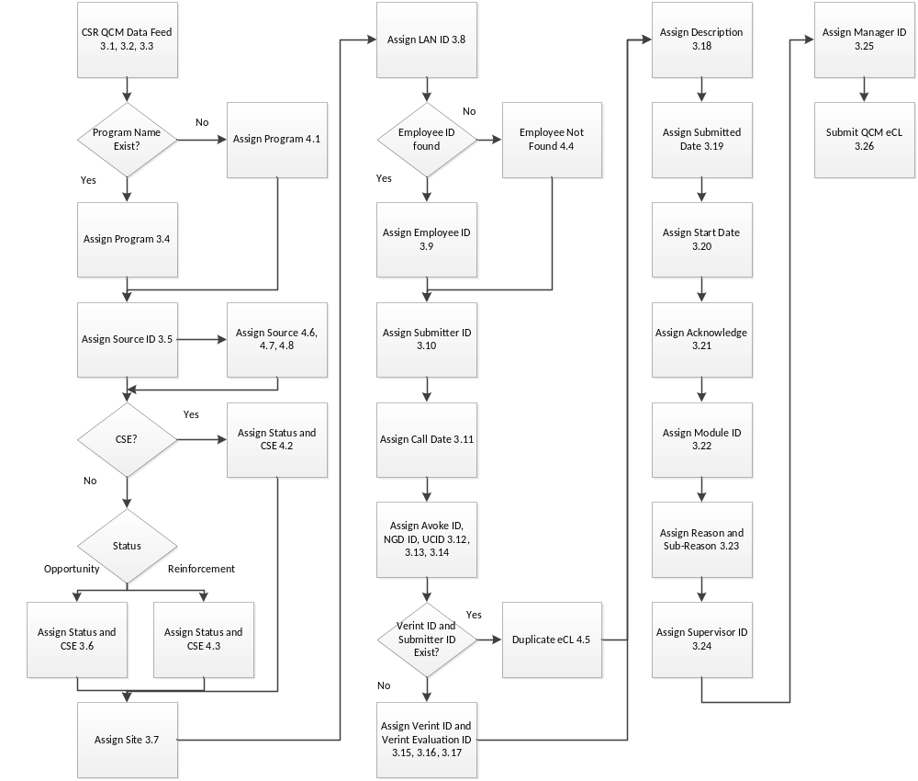
Figure 1 – CSR Quality Call Monitoring eCL Submission

